# S3 (Simple Storage Service)

**Q.** How to create a Bucket?

* Firstly, go to the AWS s3 tool.
* Then click on the create bucket.
* Buckets are containers for data stored in S3.
* Two types of buckets chose as per your required.
* 1. General purpose, 2. Directory.
* Create your bucket name, Bucket name must be **unique** **‘mydemo.bucket’** within the global namespace and follow the bucket naming rules.
* 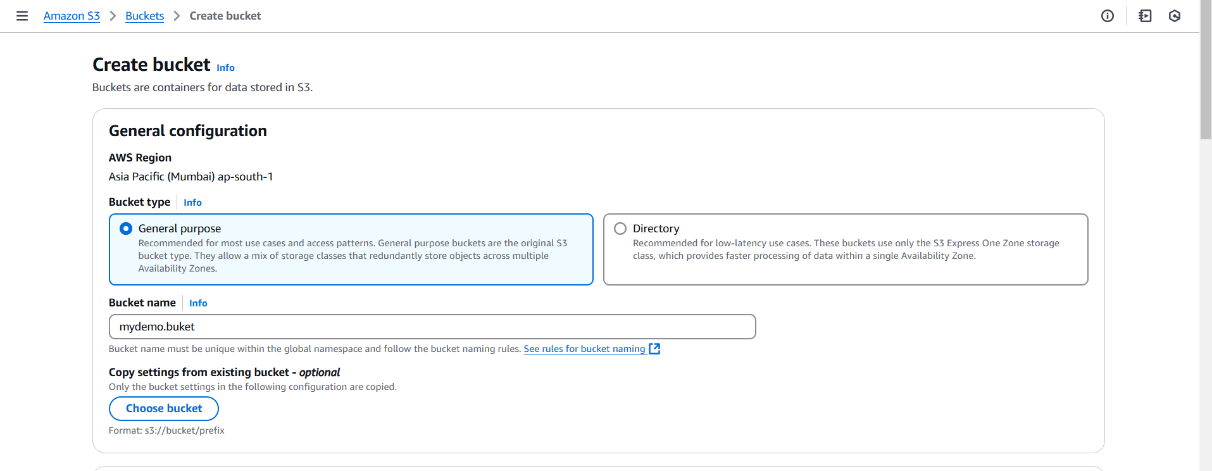
* **Object Ownership**

1. ACLs disabled (recommended)
2. ACLs enabled

As per your required

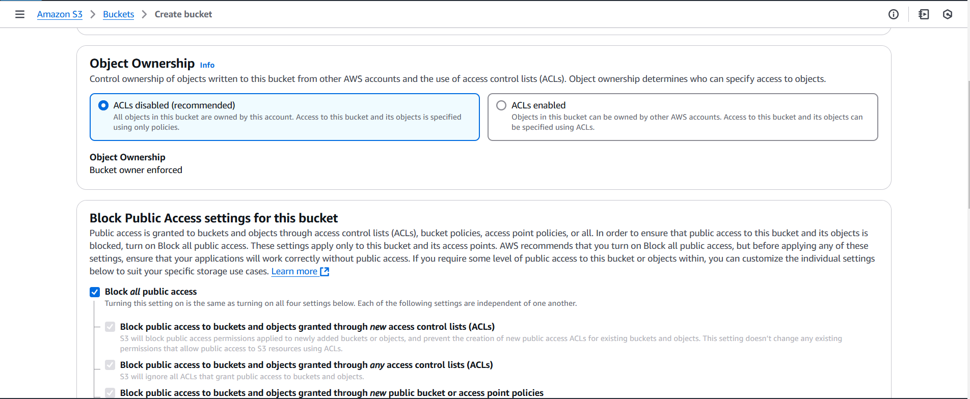

* After then **Block Public Access settings for this bucket.**

**Block *all* public access use as per your required.**

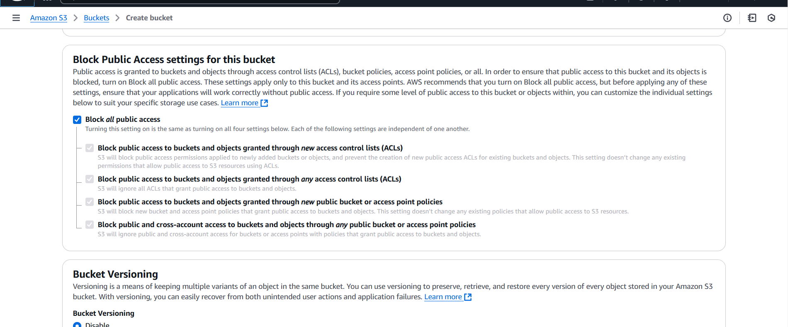

* **Bucket Versioning**
* Disable
* Enable
* **Tags - *optional***

You can use bucket tags to track storage costs and organize buckets.

* **Default encryption**
* Server-side encryption with Amazon S3 managed keys (SSE-S3)
* Server-side encryption with AWS Key Management Service keys (SSE-KMS)
* Dual-layer server-side encryption with AWS Key Management Service keys (DSSE-KMS)

Choose as per your required.

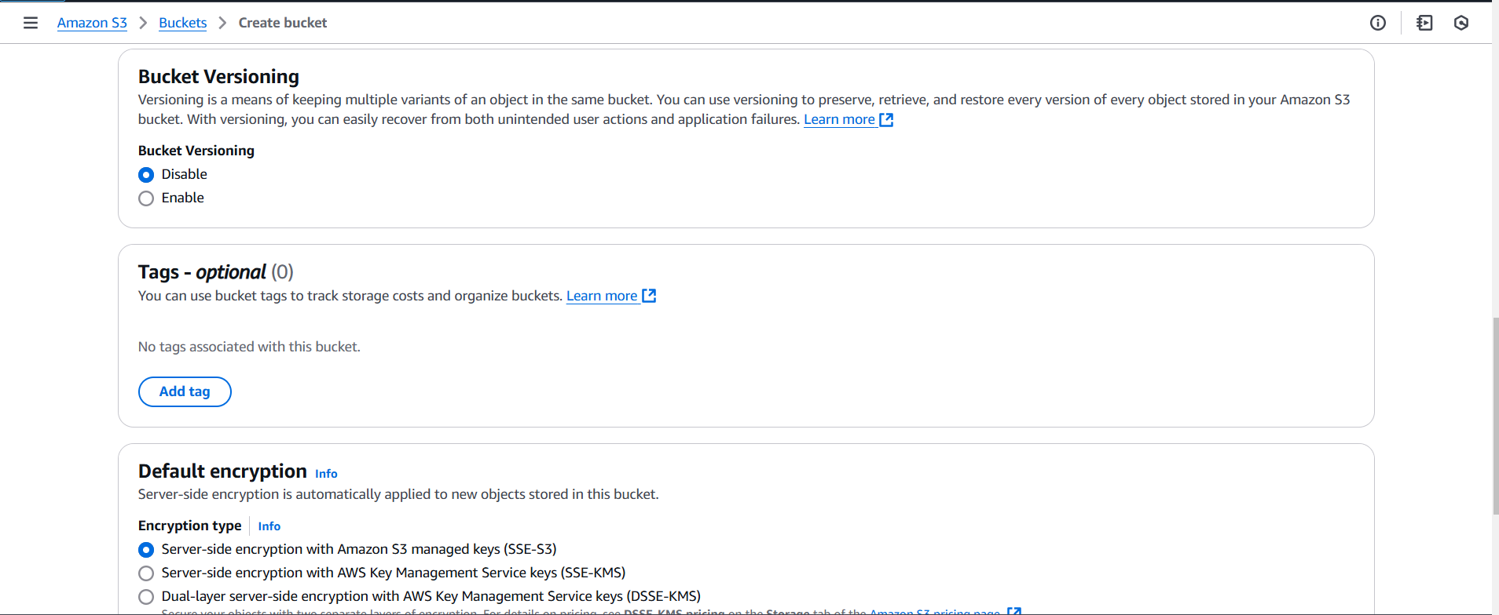

* **Bucket Key**
* Disable
* Enable
* Check all the box after then click on the **Create Bucket.**

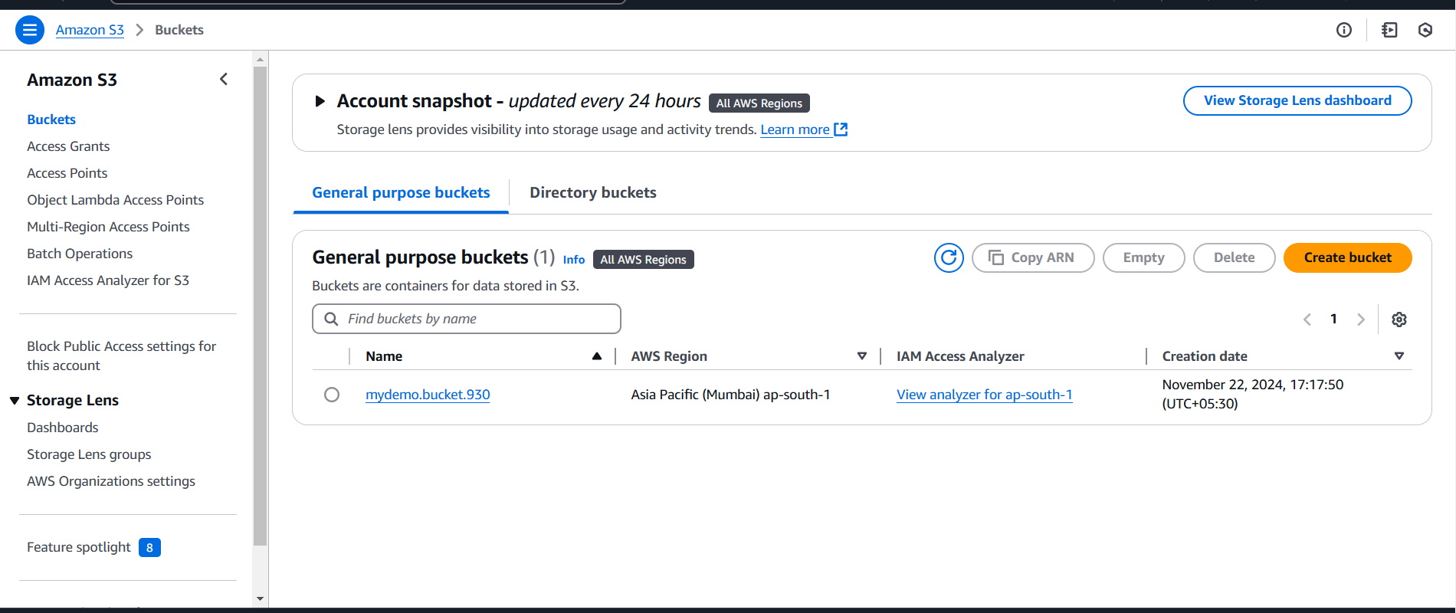

**Q. How to upload and manage the bucket file?**

* If you create the bucket, then click on the bucket **‘****mydemo.bucket’**.
* When you are entering the bucket click on **Upload.**
* **Files and folders**

1. Add files
2. Add folder

Select as your need.

* Select your **Objects** and click on **upload**.
* 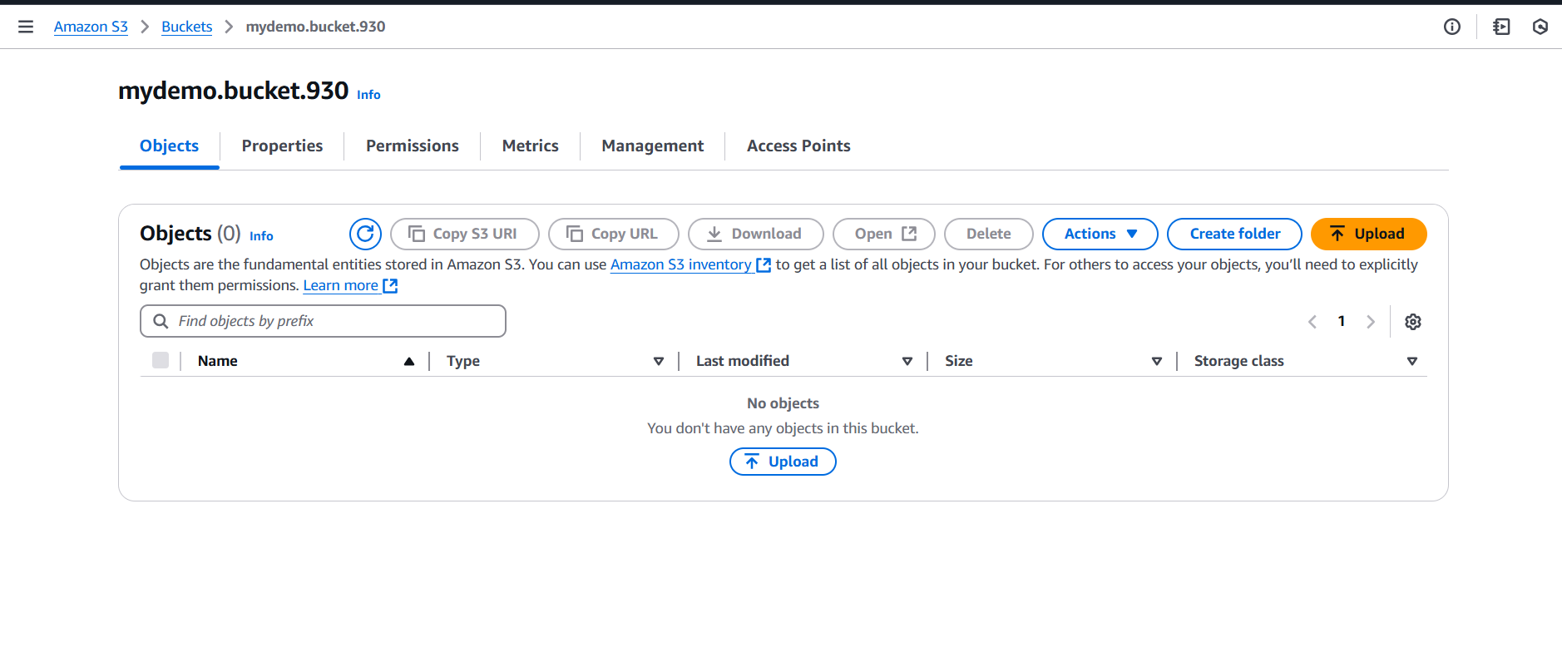

**Q. How to make it public uploading file?**

**If you want to make any uploading file public then there are three steps for it:**

**Step: - 1**

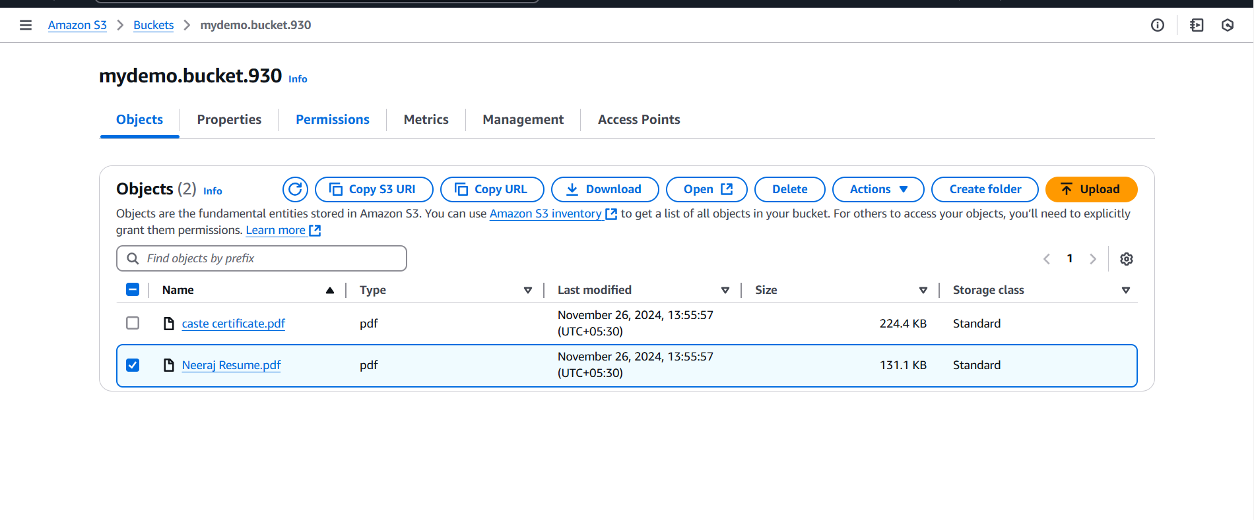

* Select the upload file.
* After then go to the **Permissions.**
* Edit the **Block public access (bucket settings).**
* **‘Uncheck’ Block *all* public access** Save changes. 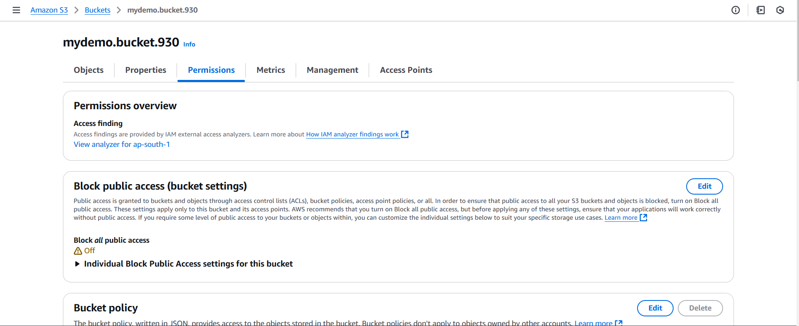
* 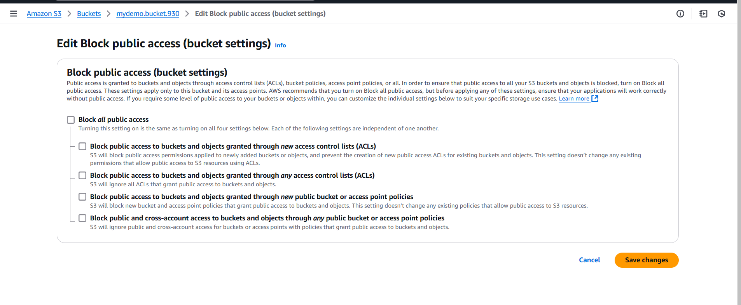

**Step: - 2**

* Select the upload file.
* After then go to the **Permissions.**
* Then scroll the page and select **Object Ownership.**
* 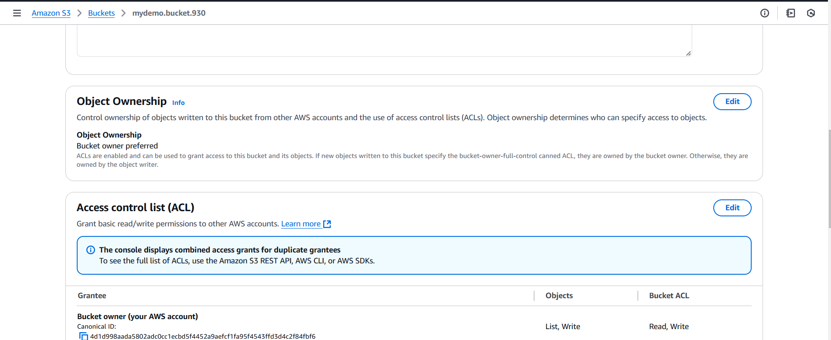
* Click on edit **Object Ownership.**
* Then click on **ACLs enabled.**
* 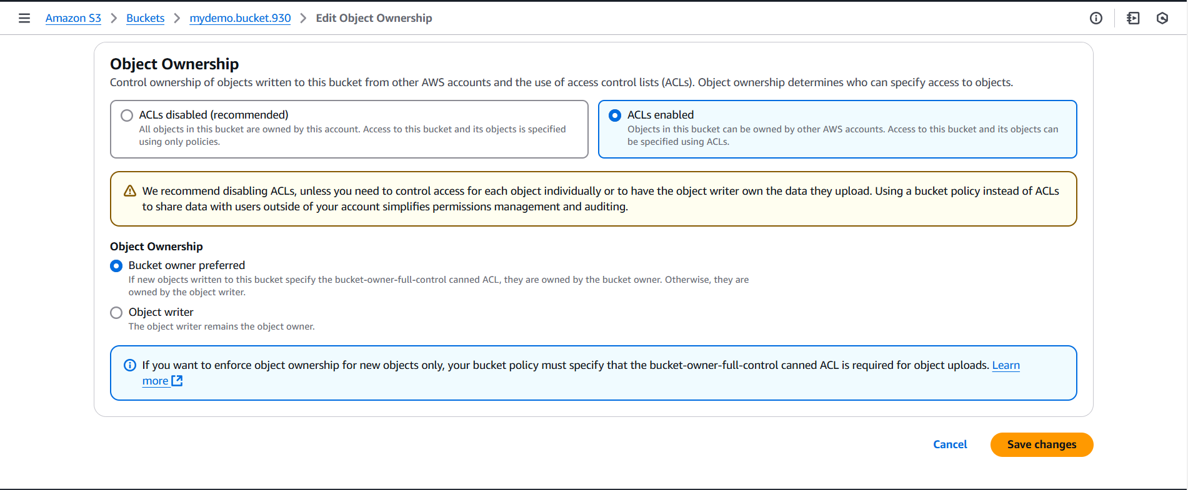
* **Then save changes.**

**Step: - 3**

* Select the upload file.
* Go to the **Actions.**
* Scroll the section and select **make public using ACL.**

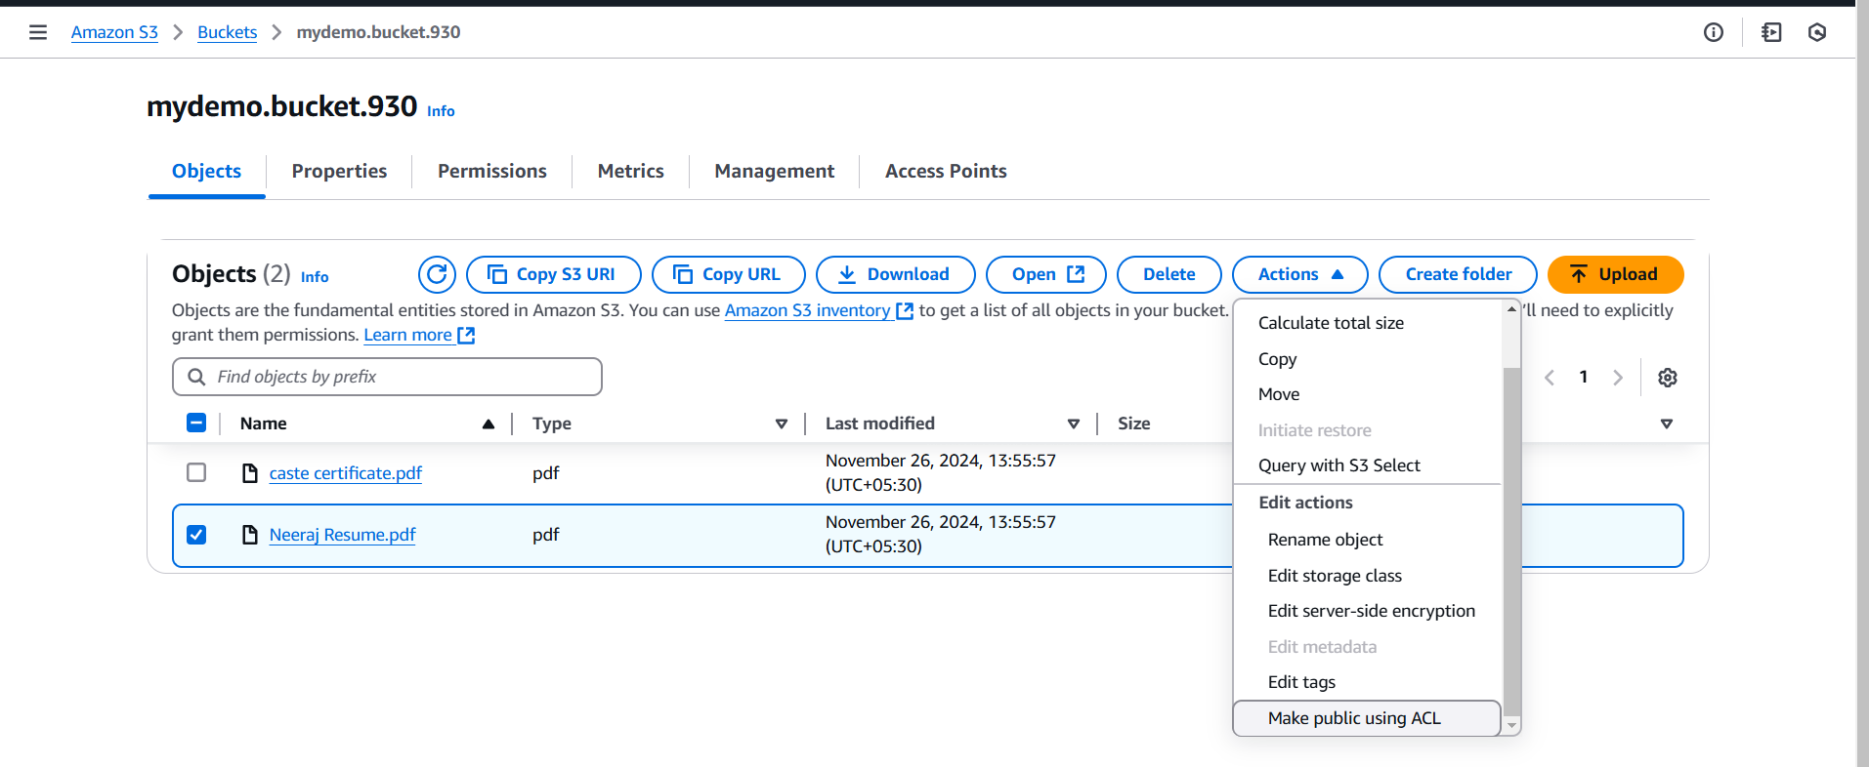

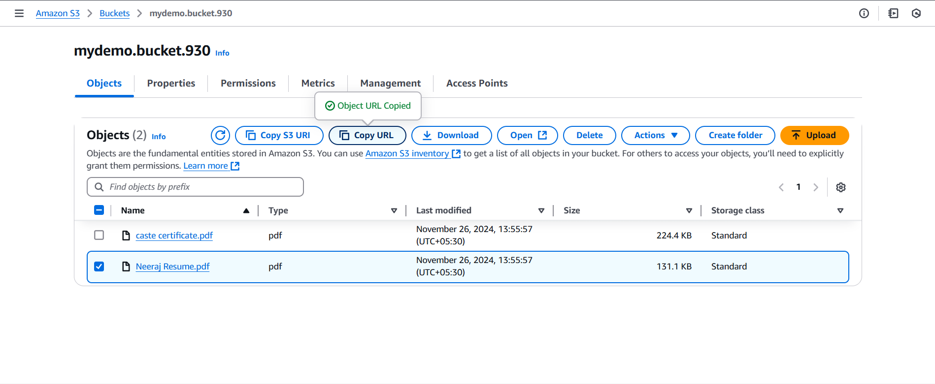

* **Click on the make public.**

**Select the file and Copy URL go to the any browser paste it.**